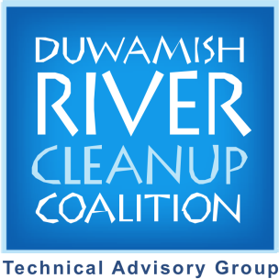
Duwamish Valley Clean Air Program
Moss Study
Community Fact Sheet

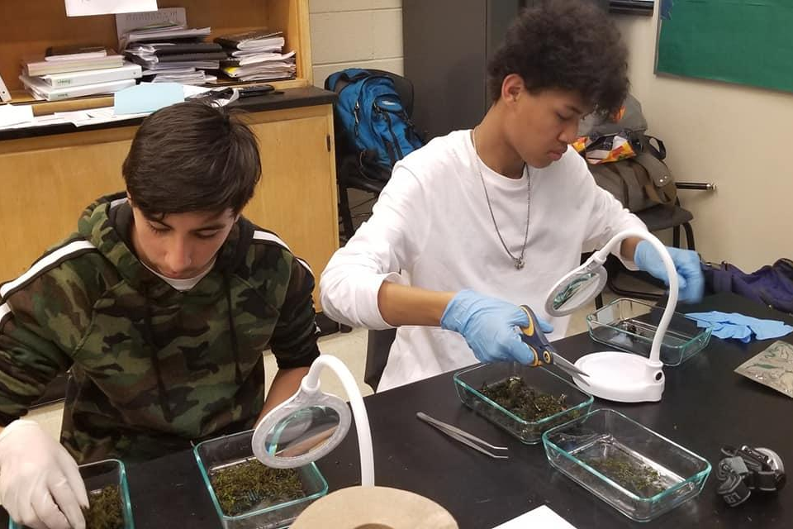
Maxey tahay “Moss Study”?

Dadka ku nool Duwamish Valley waxey doonayan meel ee ku nooladan iyo ku shaqeyan uu hawada gasho ee tahay mid dilaysa caafimaadkooda iyo noloshoda (Duwamish Valley Vision 2009).
Baaritaan cusub ee qaatay Duwamish River Cleanup Coalition’s Clean Air Program wuxu cawinaya in an sameyno aragti qiyaasayso inta bir kujirto Duwamish Valley. Bir wu iskasoo baxaa meelkasti, laken magaloyinka iyo warshadaha waxey ku badanyihin bir iyo qiqa ka imado gawarida ama warshadaha. Hadii ay bir yaryar hawada ku jiran wey gali karan wadnaha iyo sababi karan dibatoyin caafimaad.
DRCC’s Duwamish Valley Youth Corps wuxu la xirirey scientists dowladha sare ka socdo US Forest Service, dowladha hoose iyo jaamacadaha, odeyasha xafadaha, iyo dadka ka hadlo cafimadka in ay hormariyan bulshada mashruuc uu cabiro birta culus ku jiro mosska geedaha. Markaan isticmalnay habab bulshad kaqaybgalashu lex iyo labaatan dalinyaro ka sucdu Duwamish Valley waxey barteen sida luu uruuriyo moss samballo oo tilmamo qiqa hawada Georgetown iyo South Park. Mashruucan wuxu ujeeda in maclumadkan la so ururiyay mosska samballohisa in an yarayno qiqa hawada iyo ugu dambaynta hagaajinta caafimadka bulshada.

Sababta Duwamish Valley?

Dadka ku nool Duwamish Valley waxey leyihin dimashuyin ku xiran qiqa hawada kujirto ka badan meelaha kali Seattle, oo ay ka mid yihin labolab haarka carurta isbitalka lugeyu neefta inte cadiga ahayd magalada (Duwamish Valley Cumulative Health Impacts Analysis 2013). Aagana wuxu yahay harunta uu weyn warshadaha King County iyo wuxu leeyahay waddo weyn iyo wadoyinka taraafikada kawas uu ah ilaha guud ee birta culus iyo wasakhooyinka kale ee hawada.

Moss waxa luu isticmali kara “bioindicator” qiqa hawada. Bioindicators wa waxyaabaha nool uu na caawiyo in an fahanu waxa kadacayo deegaanka. Tusaalaha ugu caansan ayaa ah “Shimbirta kujirto guudka duxusha” uu bare la isticmaali jiray in ay sheygan marka ay hawada nuquto halis ( hadi uu dintu, hawada waa halis) moss waa kuwa uu fican bioindicatorska maxaa yeelay xididdada maley iyo waxkasti waxay ka qaatan hawu iyo nafaqu cirka.

Yaa baritaankaan wada?

US Forest Service wuxu iskaashi lala yeeshey Duwamish Valley Youth Corps in uu uruuriyo mosska geedaha inuu isticmaalo “Bioindicators” ku tusayo inta qiq kujirto hawada bulshadaha Duwamish Valley. la-hawlgalayaasha taageeray waxa ka mid ah Duwamish infrastructure Restoration Team(DIRT Corps), Just Health Action, Street Sound Ecology, City of Seattle’s office of Sustainability and Environment, Western Washington University’s Huxley College of the Environment, iyo the University of Washington's Department of Environmental and Occupational Health.

Ujeedada mashruuc wuxu aha baaritan lugu sameyo bulshada wada hawlgalayaasha lugu daray hanuun ka suucdu cilmi yaqaane uu ku jiru kuxda in ay uruuriyaan iyo diyaariyaan samballo moss in laga baaro bir culus. Hadi lugu guulaystu, natiijada waxa luu isticmaalaya hagis in hawada nadaafad keedah la ilaaliyo Duwamish Valley iyo la ogeysiiyo tabaha yareynta luu isticmaali karo in la ilaaliyo dadka cafimaadkuda ku nool iyo ka shaqeeyo aaga.

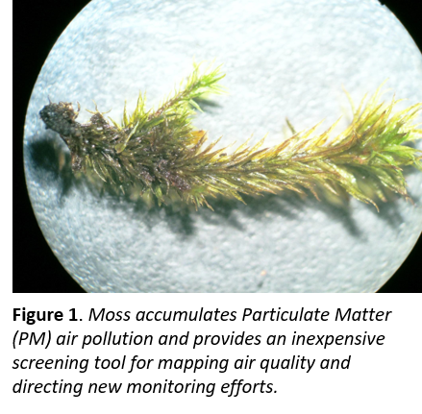
Maxaan baranay?

Dalanyaro la tobaray ka socdu Duwamish Valley Youth Corps waxey uruuriyeen siddeetan samballo mosska geedaha uu ku yaalo South Park iyo Georgetown 2019. Cilmi yaqane waxey soo uruuriyeen labaatan samballo dheeraad ah in ah isbarbar dhiggeen samballaha ee uruuriyeen dallanyarta. Samballa dhamaan waxa laga baaray shan iyo labaatan nooc uu birta culus ah iyo waxyaabo kale US Forest Service shaybaarkisa. Natiijooyinka ugu waa weyn waa:
- Samballaha ee soo uruuriyeen dallanyarta waxay isku dawaaden kuwa ay cilmi yaqaneta soo uruuriyeen, waxey muujinayeen in dallanyaro laso tababarey way so uruurin karan samballo lagu kalsoonaan
- Heerka sunta Arsenic, Chromium, Cobalt iyo Lead lago samballay Duwamish Valley waxey ka sareeyeen baaritaan la mid ah mosska Seattle jardiinohisa iyo meelaha la deggan yahay
- Bir ururinta laga helay samballaha waxey uu sareeyeen meelaha warshadaha ee South Park iyo Georgetown, gaar ahaan dhinaca Duwamish River, iyo way hooseyaan meelaha ladaggan yahay

Faraqi ugu weyna waa waxa u dhexeeya heerarka birta kujirto mosska Duwamish Valley iyo heerarka lugu arkay baritaanada waxey ahaayeen sunta arsenic iyo chromium. Nambaraha hoose waxey tuseysa khariidadaha sunta arsenic iyo chromium macluumaad kuuda iyo mid “kala firidhsan” numbaran tusaayo sida Duwamish Valley macluumaadkeeda labadaan bir siday isbarbar dhigaan Seattle jardiinihisi iyo Portland baaritankisa.
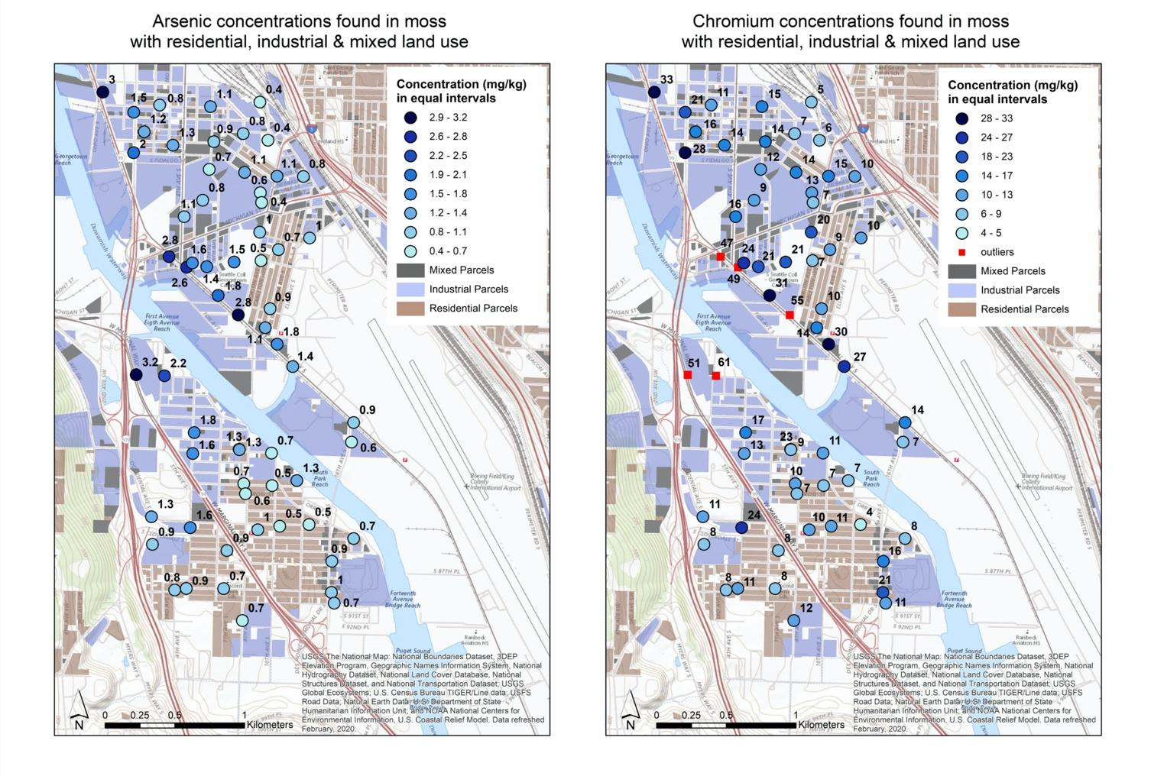
Figure 2: Dibicyada iftiinka waxey tuseysa meesha samballaha mosska uruurintida kuyar tahay sunta arsenic iyo chromium laga so qaaday. Uruurinta way badataa meesha dibicyada madowbaadeen iyo kuwa fugfug wa casaan. Meesha bluugana waa warshadaha iyo meesha brownka waa deganaansho.

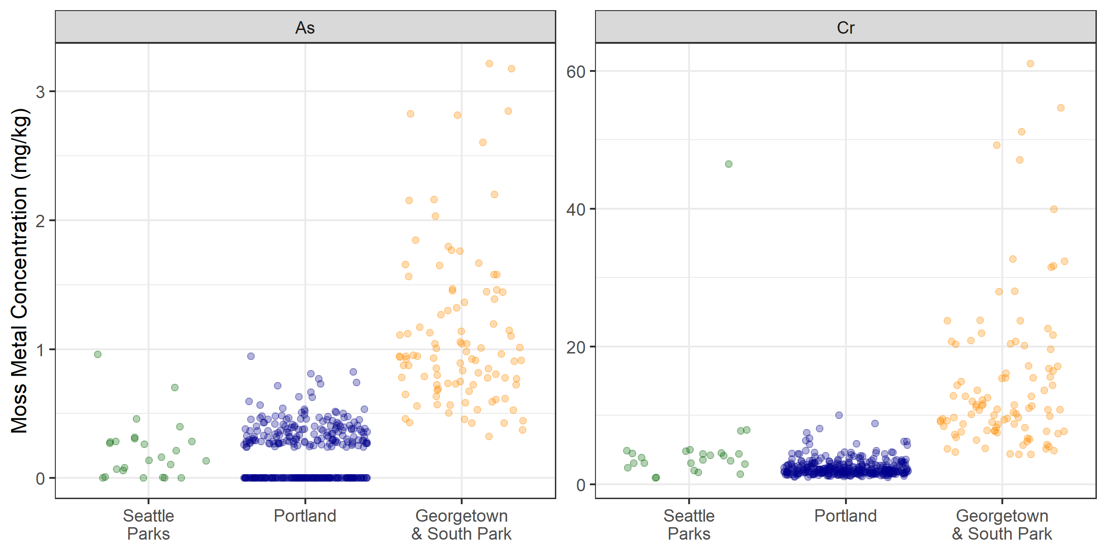
Figure 3: Samballaha ka yimid jardiinooyinka Seattle waa akhtar, kuwa Portland wa bluug, iyo kuwa Duwamish Valley waa oranji. inta dhexdhexaadka sunta chromiumka ku jirta mosska Georgetown iyo South Park wuxu aha 11.1mg/kg–u dhow labolaab into dhexdhexaadka Portland uu ah 4.6 mg/kg iyo u dhow sadexlab laga helay jardiinooyinka Seattle(3.9 mg/kg). Intaa waxaa dheer 98% iyo 94% laga helay Georgetown iyo South Park sunta chromium iyo arsenic waxey ku badnaayin moss iyo siday u kala horreeyaan way ka badnaayen degaanaha Portland
.
Maxay ka digin tahay?

Majirtu heerar deegan ama caafimaad kuu qiyaasaayo inta bir ku jiro moss. Macluumaadka laga helay baritaankaan waa tusaali qiqa hawada ku jiro, ma ahan qiyaas tuusan. Xiriirka u daxaayo uruurinta birta ku jirto moss iyo waxay dadka naafsanayaan lama uga. qalabka hawada cabiru waa lu bahanyahay in lagu ugaadu ita bir kujirto hawada. Baritaan dheeraad ah ayaa luu baahan yahay in lugu ugaadu hadi ee garayaan heer ay dilaayaan caafimaadka dadka meesha ka shaqeeya iyo kuwa ku nool.

Portland waxa ka jiru mosska macluumaadkisa sida luu isticmaalay in lugu ugadu meesha la digi laha qalabka hawada isha lugu hayo. Qalabka waxa ladigay meelaha ee ku badnaayen mosska birta lugu helay iyo lugu xaqiijiyay in labo bulshaduud mosskuda u farabadnayiin bir. Tayoda hawada labadaa bulshaduud wuu hajaajey. Natiijooyinkas waxa isticmalay Governor Kate Brown in uu sameeyo programka Cleaner Air Oregon uu ah isbadal weyn sida sunta hawada luu ilaaliyo gobalka uu dan. Environmental Protection Agency wuxu sameeyay xeerar adag qiqa ee bixin karaan kuwa sameeyo artiska miraayada dalka guud ahanba.

Maxaa ku xiga?

US Forest Service waxey siwadaysa in ay falaqayn ku si wadaan baaritaankan iyo waxey soo saarayaan warbaxin damaaystiran sanadka dambey.
Puget Sound Clean Air Agency (PSCAA) wuxu haaysta xabad qalabka hawada ilaaliyo South Park/Georgetown aagisa laakin ma cabiru uruurinta birta. Wakaalada wuxu radinaya maalgelinta in uu ku daru qalabka hawada ilaalisu meelaha uu baaritaankaan uu ka heley bir uruurinta ubadan.
Imika, DRCC, US forest Service, PSCAA, iyo mashruucyo kali caawistada ayee u baahan yehiin. Bulshada xubnahisa waan ku yereynaa in ay nala caawiyaan go’aansasho meelaha caawista uu badan u baahan qalabka hawada dheerad ah iyo talabo kali an qadan karnu. Waxaa ka mid ah in aan disnu derbi ama beerno geed inta u dhexeeyo warshadaha iyo deganaanshaha in aan qabsano qiqa hawada, yareeno traffika meeshey maraan deganaanshaha agtuuda iyo baarno shaqaalaha warshadaha ka shaqaayo caafimaadkuuda in uu yaraaday qiqa hawada iyo wasakhda warshadaha.
Bulshada waxey ku jiri dunta duurashada su’aalaha la is weydin dunu iyo talaabada la qaadan duunu. Macluumaad kali hadii ad dunaysid na so email garay contact@duwamishcleanup.org

Soo booqo www.duwamishcleanup.org/moss-study macluumaad kali hadii ad ka qabtid mashruucan.

wada hawlgalayaasha waxbarashada waxa kamid ah: the US Forest Service, State and Private Forestry, Pacific Northwest Region; Urban Waters Federal Partnership; Duwamish Infrastructure Restoration Team (DIRT Corps); Just Health Action; Street Sounds Ecology; the City of Seattle’s Office of Sustainability and Environment; Western Washington University’s Huxley College of the Environment; iyo the University of Washington Department of Environmental and Occupational Health Sciences.

Su’aalo? Fadlan nalasoo xirir:
(206) 251-2038 • contact@duwamishcleanup.org • 7400 3rd Ave South, Seattle, WA 98108

DRCC elevates the voice of those impacted by Duwamish River pollution and other environmental injustices to advocate for a clean, healthy, equitable environment for people and wildlife. We promote placekeeping and prioritize community capacity and empowerment.

